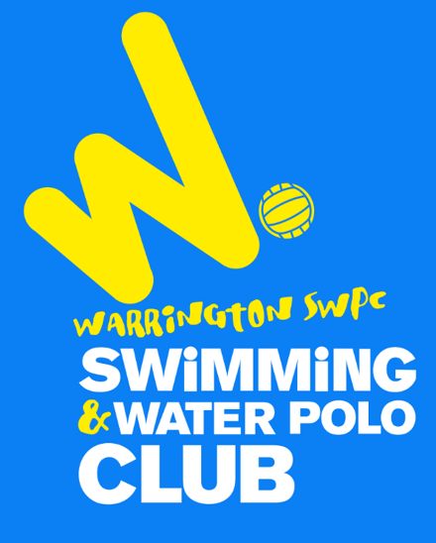
WATER POLO 2021
Why not give it a try?
Did you know that our club is very successful at playing Water Polo?

Many of our players have achieved great success in the sport –Water Polo is fantastic for swimmers and most of all its great fun!

This year we are looking for boys and girls ages 10-16 who are existing swimmers to apply their skills to this fast-paced exciting team sport.

Come along to one of our sessions and have a go and see if you enjoy the sport.

The first session is free to anyone and also to any guests who you bring along. You can then attend two further free sessions at Orford on Saturday4:00pm- 5:00pm.

To register and find out the next available session for a trial Membership Page
email warringtonwaterpolo@gmail.com or call 01925967172
For more information on the sport visit Website water polo
